**MDF Rose Engine Lathe 2.0**

**with Stepper Motor Drive**



**Instructions for Building**

**Control System for**

**Spindle Stepper Motor**

**Version 1.0**

**22 January 2021**

This document is intended to help one unfamiliar with the MDF rose engine to build one easily. It is designed to go with the kit you can purchase from [www.ColvinTools.com](http://www.ColvinTools.com).

There are some variations from the ideas documented by Jon Magill at [www.rogueturner.com](http://www.rogueturner.com/). Where this is the case, we have tried to document such changes and provide the reason for the change.

This document is also designed to use a stepper motor for driving the spindle.

If you have any questions, please contact us at [ColvinTools@Gmail.com](mailto:ColvinTools@Gmail.com).

Good luck.

Rich Colvin & Jack Zimmel

Table of Contents

Getting Started 4

Overview of Connections 5

Bill of Materials 6

Use Standard Electrical Plates for Connectors 8

Where to Put the Controls 9

Option 1: Use the Box Designed for the Full System 10

Option 2: Use a Different, Smaller Box 15

Option 3: Place all Parts Inside the Lathe’s Base 18

Connecting the Electronics 20

Configuration Settings 26

Motor Connections 32

Attaching the Stepper Motor to the Headstock 34

Document Version History 38

# Getting Started

As you get started with building this machine, please consider making the machine according to the outlined instructions. There are a boatload of ways you can modify this, and, quite frankly, the MDF rose engine encourages experimentation. But it is best to attempt those modifications after understanding how it works. Some ideas which sound grand may not appear so after understanding how the machine works (we speak from experience).

If you have any questions on the terminology in this document, check out the “Ornamental Turning Book of Knowledge” ([www.OTBoK.info](https://www.otbok.info/)).

This document outlines the approach for wiring this machine using a Pololu Tic 36v4 High-Power Stepper Motor Controller.

|  |  |
| --- | --- |
| Advantages | Disadvantages |
| * The cost is significantly lower than the full system design (which uses the Nextion display and Rose Engine Controller Spindle and Three Axes V002c PCB). * The Pololu Tic is small and can be placed pretty much anywhere (it is only 1.05” x 1.5”). * This is simpler to implement. * If the implementer chooses to upgrade to the full controls system later, there is little investment which is lost (it is only the Pololu Tic and the rotary encoder). | * This design can only control the spindle’s stepper motor. * It could be duplicated for a 2d stepper motor; however, the two would not be synchronized. |

Standards are outlined in a companion document and are used for the compilation of this document.

Cautions

1. **Do not perform any changes to this system when the system is powered on.** Power down and unplug the system before attempting any work.
2. If your local electrical code requires for any differences from what is documented here, those requirements take precedence over this document.
3. If you feel uncomfortable with anything in these instructions, consider having a licensed electrician perform the work.

**Please also note:** Permission is not granted to manufacture these for sale.

# Overview of Connections

The whole system is shown in the picture to the right.



It is shown with two boxes, one blue and another orange. This is because these components are probably separated into separate boxes or locations.

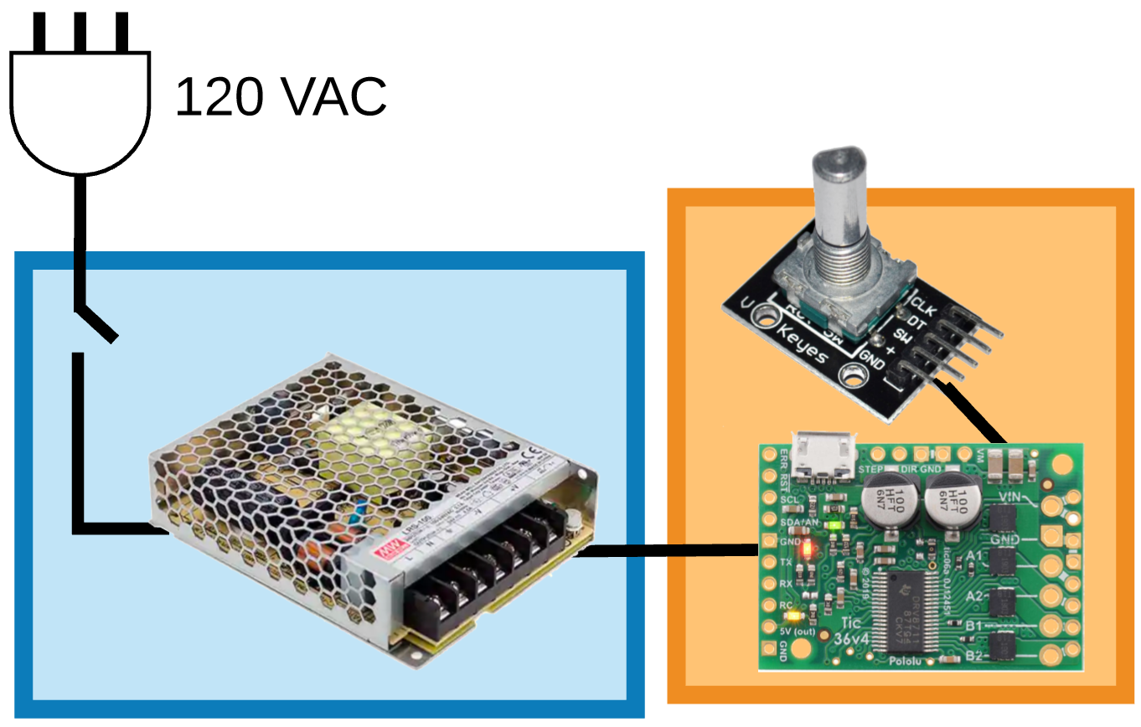

The system consists of these items:

**Blue Box**

1. Power switch
2. 24 V power supply

**Stepper Motor on the Spindle of an**

**Original MDF Rose Engine Lathe**

**Orange Box**

1. Pololu Tic 36v4 High-Power Stepper Motor Controller
2. Rotary encoder

**Not Shown**

1. Stepper motor
2. Bracket and parts to mount the stepper motor in the headstock
3. Drive gears and belt

This control system can be used on:

* MDF Rose Engine Lathe
* MDF Rose Engine Lathe 2.0

# Bill of Materials

Parts required for building this are below. The item numbers are shown in the following drawings using an orange, circled number like the one to the right. For consistency with the full, multiple stepper motor system, those item numbers are retained; however, they are deleted from this list. That is why there are gaps in the numbers.

Quantities that are based on the option selected are shown with the respective option.

| Common Materials for All Options | | | | | |
| --- | --- | --- | --- | --- | --- |
| Item # | Item | Qty | Source | Source  Part Number | Comments |
|  | **Electrical Items** |  |  |  |  |
| 109 | Tic 36v4 High-Power Stepper Motor Controller | 1 | Pololu.com | 3140 | Tic 36v4 with connectors soldered |
| 110 | Rotary Encoder | 1 | Amazon |  | Cylewet 5Pcs KY-040 Rotary Encoder Module with 15×16.5 mm with Knob Cap for Arduino (5 pcs) CYT1062 |
|  | **Electrical Items** |  |  |  |  |
| 201 | AC/DC Power Supply - LRS-100-24 | 1 | Digi-Key | 1866-3314-ND |  |
| 205 | Power Switch | 1 | Amazon |  | SPST Toggle |
| 209 | Utility box cover, 1 gang |  | Amazon | Hubbell-Raco 861 |  |
| 210 | Utility box cover, 1 gang |  | Amazon | Hubbell-Raco 860 |  |
| 211 | 3/8 in. Twin-Screw Cable Clamp Connectors |  | Local hardware store |  |  |
| 213 | Stepper Motor | 1 | StepperOnline | 23HS30-30045 | For the spindle drive  NEMA 23 bipolar 1.8°  1.9 Nm, 2.8A, 3.2V  57 x 57 x 76 mm |
|  | **Cables** |  |  |  |  |
| 302 | Cabling – 20 AWG/4, stranded |  |  |  |  |
| 303 | Cabling – 20 or 22 AWG/2 |  |  |  | Used for DC power connection. |
| 304 | Cabling – 16 AWG/3, stranded |  |  |  | Used for AC power connection.  Can cut off the female end of a grounded extension cord. |
| 305 | Crimp Connector Housing, 1x5 | 2 | Pololu.com | 1904 | 0.1" (2.54mm) Crimp Connector Housing: 1x5-Pin (5-pack) |
| 306 | Wires with pre-crimped terminals | 5 | Pololu.com | 1803 | Wires with Pre-Crimped Terminals 50-Piece, 10-Color Assortment F-F 12" |
|  | **Screws, etc.** |  |  |  |  |
| 408 | Particle Board Screws, #6, 5/8” long, flat head | 12 | McMaster-Carr | 90252A246 | Used to affix the utility box covers in place (replaces the screws that may come with the plates) |
|  | **Spindle Drive Parts** |  |  |  |  |
| 501 | Timing Belt | 1 | MiSUMi | GBN655EV5GT-90 | GT3 5mm pitch  131T / 655mm long  9mm wide |
| 502 | Spindle Pulley | 1 | Colvin Tools |  | Attached to the spindle via the flange. |
| 503 | Stepper Motor Pulley | 1 | Stock Drive Products ([www.sdp-si.com](http://www.sdp-si.com)) | A 6A55-012DF0908 | 5 mm (GT2) Pitch,12 Teeth, 0.25" Bore, 2 Flanges / With Hub, Aluminum Alloy Timing Pulley for .354 (9mm)" Wide Belt |
| 504 | Stepper Motor Attachment Bracket & Parts | 1 | Colvin Tools |  | Includes:   * Bracket with Idler * Mounting bolts, nuts, and spacers to attach to headstock * Mounting screws to attach stepper motor |

# Use Standard Electrical Plates for Connectors

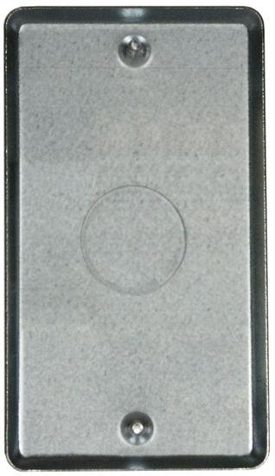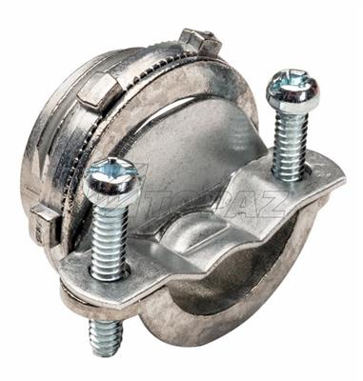

### Power Infeed

Use a 1-gang plate with the hole punched out for the cable strain relief. Secure the power cable in place using the 3/8 in. Twin-Screw Cable Clamp Connector. Wait until later to tighten the screws holding the power cable into place.

**Option 1:** Mount to the box designed for a full system

**Option 2:** Use one for the 120 VAC power infeed, and a separate one for the 24 VDC power outfeed. Mount to the back of the base.

**Option 3:** Mount to the back of the base.

### Power Switch

Use a 1-gang plate which is blank. Drill a ½” hole in the center and

secure the power switch to it.

If you choose to put all the controls in the case of the machine then this would be mounted to the front.

**Option 1:** Mount to the box designed for a full system

**Option 2:** Mount to the front of the base.

**Option 3:** Mount to the front of the base.

# Where to Put the Controls

There are some good options about where to put the

* Pololu Tic 36v4 High-Power Stepper Motor Controller (which is small – 1.05” x 1.5”) and
* 24 V power supply

The best options are:

1. Use the box designed for the full system (see also, “Instructions for Building the Stepper Controls”) – pg. 10.
2. **Use a different, smaller box – pg. 15** 🡸 This is the recommended approach
3. Place all parts inside the lathe’s base – pg. 18

Regardless of the option chosen,

1. The rotary encoder and the power switch, both need to be easily accessible, and
2. The power infeed and power switch should be implemented as shown on the prior page.

# Option 1: Use the Box Designed for the Full System

**Option 1**

One consideration for building the enclosure is for using the controls box as outlined for the full controls system. This may be a bit of over-kill on space utilization, but it accommodates upgrading later to the full system if that is what is desired.

Building the box is outlined in a separate document, “Instructions for Building: Control System for Multiple Stepper Motors”.

With this option, the spindle stepper motor should be connected to the controls box using a GX-16/4 plug as outlined below.

### Bill of Materials for Option 1

Parts required for building this option are below. These are in addition to the items listed on pg. 6.

| Materials for Option 1 | | | | | | |
| --- | --- | --- | --- | --- | --- | --- |
| Item # | | Item | Qty | Source | Source  Part Number | Comments |
|  | | **Electrical Items** |  |  |  |  |
| 206 | | GX-16/ 4 Socket | 1 | Amazon |  | May come as a pair of sockets and plugs (i.e., including #214) |
| 208 | Utility box cover, 2 gang | | 2 |  | Hubbell-Raco 804C |  |
| 209 | Utility box cover, 1 gang | | 1 | Amazon | Hubbell-Raco 861 |  |
| 210 | Utility box cover, 1 gang | | 1 | Amazon | Hubbell-Raco 860 |  |
| 211 | | 3/8 in. Twin-Screw Cable Clamp Connectors | 1 | Local hardware store |  |  |
| 214 | | GX-16/ 4 Plug | 1 | Amazon |  | May come as a pair of sockets and plugs (i.e., including #206) |
|  | | **Screws, etc.** |  |  |  |  |
| 401 | | Nylon Spacer (Unthreaded) for #8 screw – ¼” OD, ¼” length | 2 | McMaster-Carr | ﻿94639A293 | Used to add space below the Pololu Tic when affixing it to something. |
| 406 | | Sheet Metal Screws, #4, 3/4” long, round head | 2 | McMaster-Carr | 90935A137 | Used to hold the Pololu Tic in place. These work acceptably in the MDF for the purposes they are designed to be used. |
| 407 | | Particle Board Screws, #6, 3/4” long, round head | 20 | McMaster-Carr | 91555A115 | Used to hold the case pieces together (i.e., to affix the ¼” MDF sides to the ¾” MDF top and bottom) |
| 408 | | Particle Board Screws, #6, 5/8” long, flat head | 12 | McMaster-Carr | 90252A246 | Used to affix the utility box covers in place (replaces the screws that may come with the plates) |

A recommended layout for the front is shown below.

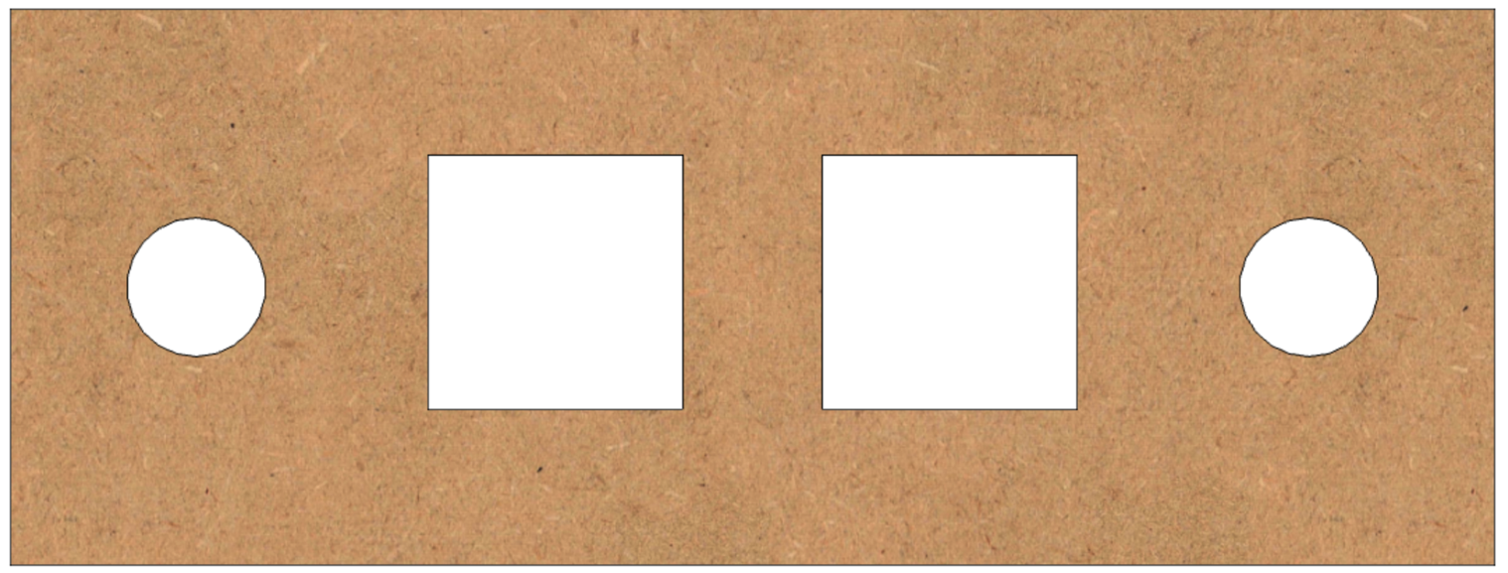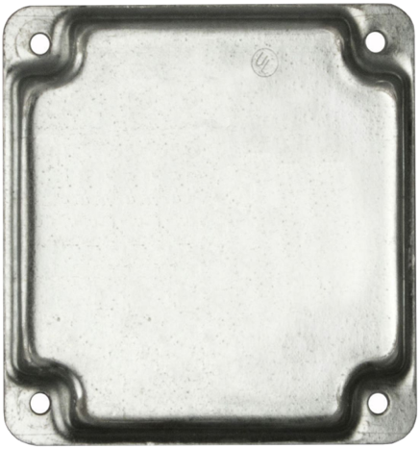

**Spindle**

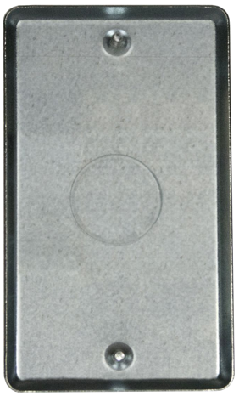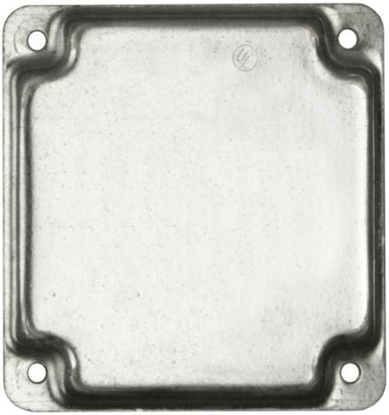

**Speed**

**Rotary Encoder**

**GX-16/4 Plug**

**Power Infeed**

### Stepper Motor Plugs



**Z Axis**

**Spindle**

**B Axis**

**X Axis**

1 ¾”

1 ¾”

Use a 2-gang plate which is blank. If you are planning to upgrade

later, consider going ahead and drilling all 4 holes. They are each 5/8” diameter.

Even if you choose to not drill the holes, go ahead and mark them with a punch for drilling later (it is much easier to do that now).

Label the spindle plug.

**5/8” dia**

### Other Plugs

1”

1”

1”



Limit Switches

36

34

35

39

37

38

¾”

1”

**Spindle Speed**

Use a 2-gang plate which is blank.

If you are planning to upgrade later, consider going ahead and drilling the 6 holes which are each 15/64” diameter. Label these as:

* Limit Switches
  + 34
  + 35
  + 36
  + 37
  + 38
  + 39

Even if you choose to not drill the holes, go ahead and mark them with a punch for drilling later (it is much easier to do that now).

For the rotary encoder, drill 1 hole that is the diameter necessary for the rotary encoder. Center it left to right and 1” from the outer edge. Label it as “Spindle Speed”.

# Option 2: Use a Different, Smaller Box

**Option 2**

This is the recommended approach, especially if you want to add this capability to one of the original MDF rose engine lathe (upgrading your lathe to the MDF rose engine lathe 2.0 is not required).

### Bill of Materials for Option 2

Parts required for building this option are below. These are in addition to the items listed on pg. 6.

| Materials for Option 2 | | | | | |
| --- | --- | --- | --- | --- | --- |
| Item # | Item | Qty | Source | Source  Part Number | Comments |
|  | **Electrical Items** |  |  |  |  |
| 206 | GX-16/ 4 Socket | 1 | Amazon |  | May come as a pair of sockets and plugs (i.e., including #214) |
| 211 | 3/8 in. Twin-Screw Cable Clamp Connectors | 1 | Local hardware store |  |  |
| 214 | GX-16/ 4 Plug | 1 | Amazon |  | May come as a pair of sockets and plugs (i.e., including #206) |
| 215 | Watertight Utility Box, 1 Gang | -- | Ace Hardware  (or similar source) | 32033 | I use the Cantex 2-3/4 in. Rectangle PVC 1 gang Outlet Box Gray |
| 216 | Box Cover, 1 Gang | -- | Ace Hardware  (or similar source) | 33368 | I use the Cantex Rectangle PVC 1 gang Electrical Cover For Single Gang FS Type Box |
|  | **Screws, etc.** |  |  |  |  |
| 408 | Particle Board Screws, #6, 5/8” long, flat head | 12 | McMaster-Carr | 90252A246 | Used to affix the utility box covers in place (replaces the screws that may come with the plates) |

For the stuff in the orange box, I recommend using a water-tight box like the one shown to the right below. It has space inside for the Pololu Tic, and the rotary encoder can be mounted in the lid. Being water-tight, it will also be good at keeping dust out.

The cabling to the spindle stepper motor can still use the GX-16/4 socket, and this will make it easier if you want to later swap this out with the mor feature-rich multiple stepper motor controls (the one running on a Teensy controller and with a Nextion touch screen).

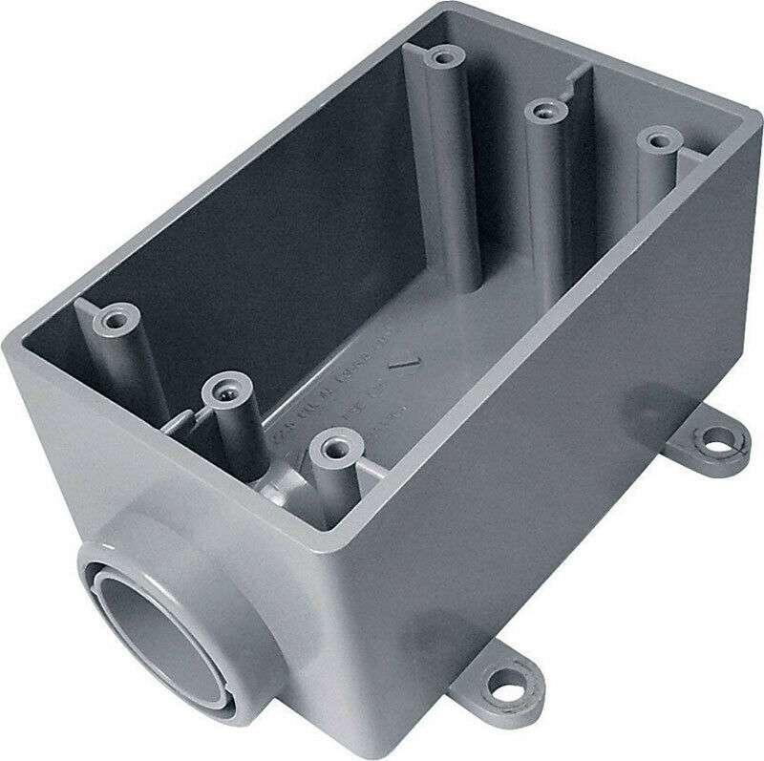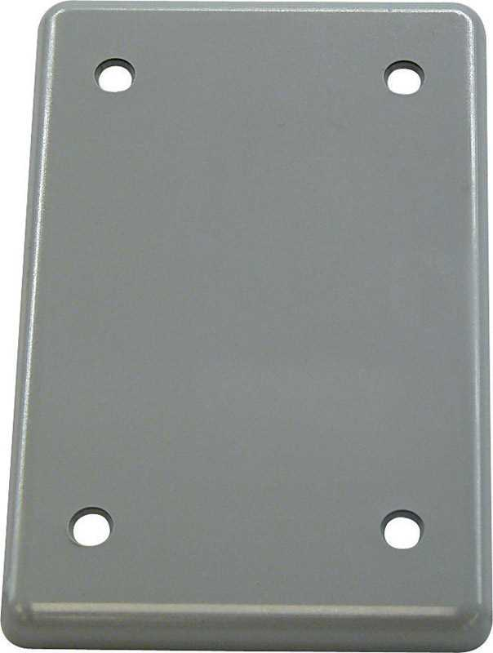

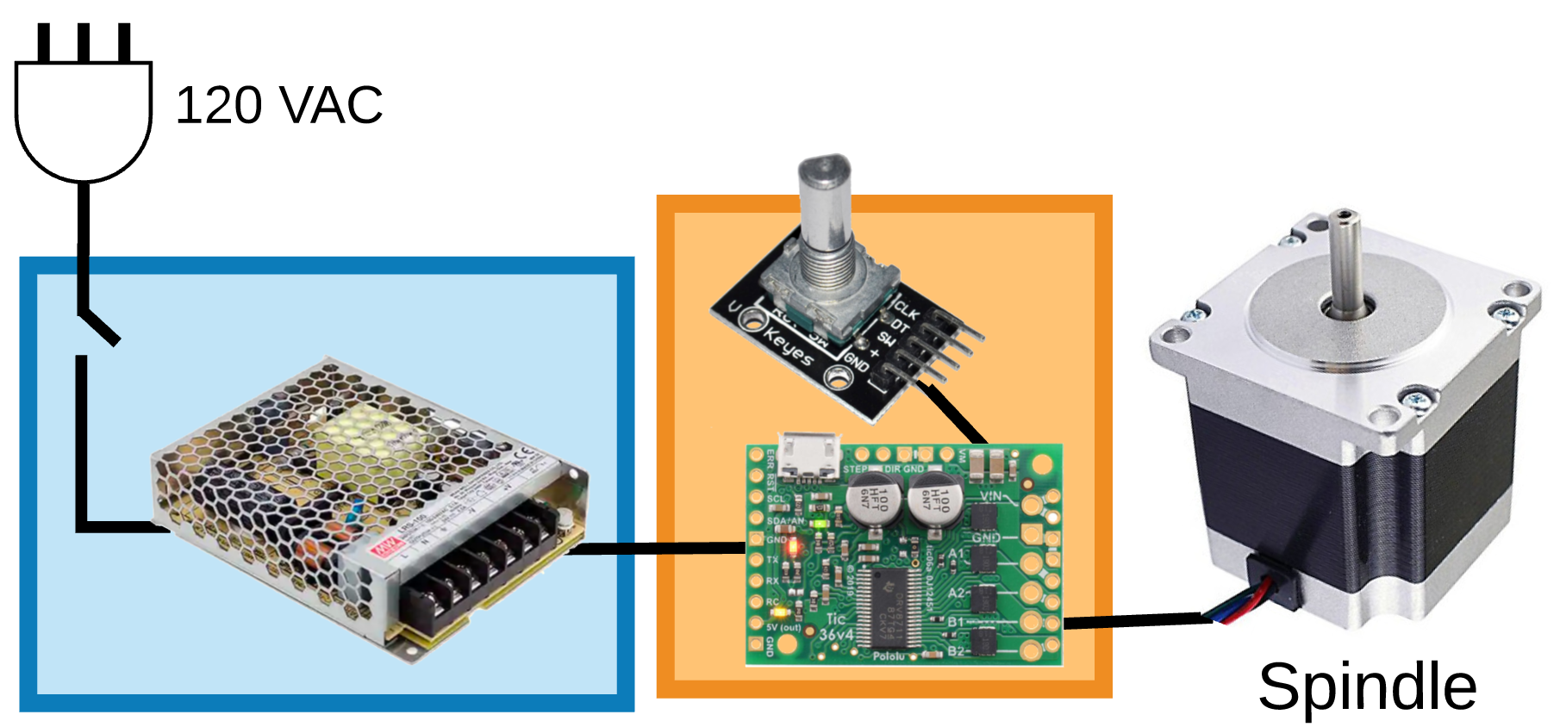

### Rotary Encoder Speed Control

A blank plate (#216) could be used. Labelling on this should be something like:

Connection of the electronics continues with **Connecting the Electronics**, starting on pg. 20.

Push to Stop

Fwd –

Rev +

Fwd +

Rev –

**Spindle Speed**

All the stuff in the blue box can easily be put into the lathe’s bed. The power supply does not take up much space, so the bed is a really good place to put it. The diagram below shows where it could be put in the MDF rose engine lathe 2.0, but a similar location could be used for the original MDF rose engine lathe.

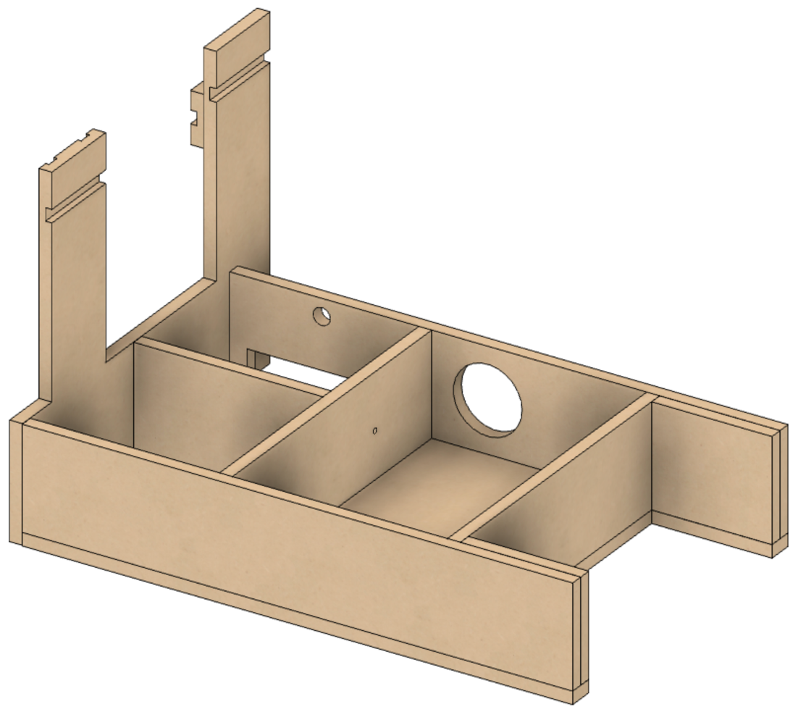

**Recommended Placement for Power Supply**

**Recommended Placement for Power Infeed**

**(120 VAC)**

**Recommended Placement for Power Switch**

# Option 3: Place all Parts Inside the Lathe’s Base

**Option 3**

A last option for consideration is to put all the stuff that is in the blue box and the orange box into the lathe’s bed. The power supply does not take up much space, so that is a really good place to put it. The diagram on the next page shows places where it could be put in the MDF Rose Engine Lathe 2.0, but a similar location could be used on the original MDF rose engine lathe.

### Bill of Materials for Option 3

Parts required for building this option are below. These are in addition to the items listed on pg. 6.

| Materials for Option 3 | | | | | |
| --- | --- | --- | --- | --- | --- |
| Item # | Item | Opt 3 | Source | Source  Part Number | Comments |
|  | **Electrical Items** |  |  |  |  |
| 211 | 3/8 in. Twin-Screw Cable Clamp Connectors | 1 | Local hardware store |  |  |
|  | **Screws, etc.** |  |  |  |  |
| 401 | Nylon Spacer (Unthreaded) for #8 screw – ¼” OD, ¼” length | 2 | McMaster-Carr | ﻿94639A293 | Used to add space below the Pololu Tic when affixing it to something. |
| 406 | Sheet Metal Screws, #4, 3/4” long, round head | 2 | McMaster-Carr | 90935A137 | Used to hold the Pololu Tic in place. These work acceptably in the MDF for the purposes they are designed to be used. |
| 408 | Particle Board Screws, #6, 5/8” long, flat head | 4 | McMaster-Carr | 90252A246 | Used to affix the utility box covers in place (replaces the screws that may come with the plates) |





**Recommended Placement for Rotary Encoder**

**Recommended Placement for Power Switch**

**Recommended Placement for Pololu Tic**

**Recommended Placement for Power Infeed**

**(120 VAC)**

**Recommended Placement for Power Supply**

# Connecting the Electronics

Attach the parts to the **Pololu Tic** using the instructions below.

### Wiring – Power Supply (LRS-100-24)

|  |  |
| --- | --- |
| Conductor Type | Stranded copper |
| Conductor Size | 16 AWG (min) |
| Cable Size | 3 conductors / cable |

#### Power Infeed

The power infeed is connected as:



|  |  |
| --- | --- |
| Wire Color | Power Switch |
| Black Incoming Power | Terminal 1 |
| Black Outgoing Power | Terminal 2 |



Black

White

Black

Green

|  |  |
| --- | --- |
| Wire Color | LRS-100-24 |
| Black from Power Switch Terminal 2 | L |
| White | N |
| Green | GND |

#### Power Outfeed

The Pololu Tic is powered by the LRS-100-24.



V-

VIN

GND

V+

|  |  |  |
| --- | --- | --- |
| Pololu Tic | Wire Color | LRS-100-24 |
| VIN | Red | V+ |
| GND | White (or black) | V- |

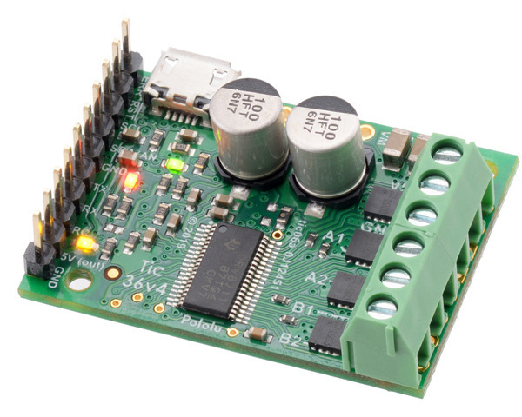

On the Tic with the soldered connectors, these are connected to the end with the screw-down block.

The two connections shown towards the top are for power.

### Signal Wiring –Stepper Motor Drivers to GX-16/4 Jacks (4)

Each of the 4 stepper motors is connected to the stepper motor drivers via GX-16/4 Jacks.

|  |  |  |
| --- | --- | --- |
| Pololu Tic | Wire Color | GX-16/4 Pin |
| A1 | Black | 1 |
| A2 | Yellow | 2 |
| B1 | Red | 3 |
| B2 | White | 4 |

|  |  |
| --- | --- |
| Conductor Type | Stranded copper |
| Conductor Size | 20 AWG |
| Cable Size | 4 conductors / cable |
| Cable Length | 6 to 8” |

**NOTE:** When soldering wires to the GX-16 jack, it is a good practice to put a small dab of soldering flux onto the terminal before beginning the soldering. This will help it happen faster, minimizing the chance for damage to the jack.

Put flux here

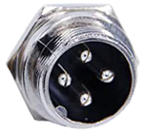

1

2

3

4

A1

A2

B1

B2





On the Tic with the soldered connectors, these are connected to the end with the screw-down block.

The four connections shown towards the bottom are for the stepper motor.

### Signal Wiring – Pololu Tic to Rotary Encoder

The rotary encoder is used to start the spindle, set its speed, and stop it.



|  |  |  |  |
| --- | --- | --- | --- |
| Rotary Encoder | Wire Color | Pololu Tic | Purpose |
| CLK | Black | RX | Encoder Channel A |
| DT | Yellow | TX | Encoder Channel B |
| SW | Blue | RC | Stop / Reset |
| + | Red | 5V (out) | VCC |
| GND | White | GND | GND |

|  |  |
| --- | --- |
| Pin | Configuration |
| TX | Encoder Input (B) |
| RX | Encoder Input (A) |
| RC | Kill Switch |
| 5V (out) |  |
| GND |  |

|  |  |
| --- | --- |
| Pin | Configuration |
| CLK | Output A |
| DT | Output B |
| RC | Active low push button switch output. When the knob is pushed, the voltage goes LOW. |
| + |  |
| GND |  |

Colors of these wires are not critical. However, it is recommended that 5 separate colors be used.



On the Tic with the soldered connectors, this is connected to the end with the soldered header pins.

Only the 1st 5 pins are used for this design.

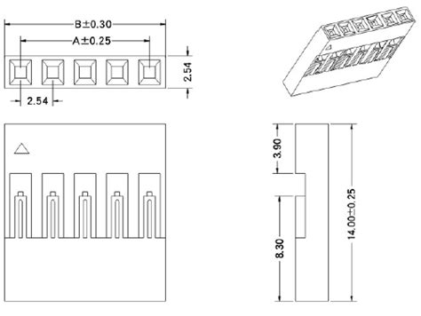

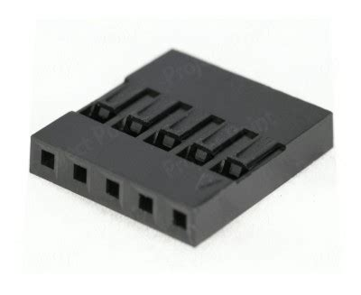When connecting the rotary encoder to the Pololu Tic, the wires are inserted into a 1x5 Crip Connector. That connector has an **arrow indicator** (q) on it.

My practice is to insert the GND wire in the arrow indicator position. Whatever your practice is, be sure to do it the same on both ends.

### Using the Rotary Encoder

The rotary encoder is used to start the spindle, set its speed, and stop it. The way it works:

|  |  |  |
| --- | --- | --- |
| Action on the Rotary Encoder | Activity on the Spindle | What Happens |
| Rotate clockwise | Spindle stopped | Spindle begins rotating in the “forward” direction |
| Rotating in the “forward” direction | Spindle speed increases in the “forward” direction |
| Rotating in the “reverse” direction | Spindle speed decreases in the “forward” direction |
| Rotate counter-clockwise | Spindle stopped | Spindle begins rotating in the “reverse” direction |
| Rotating in the “reverse” direction | Spindle speed increases in the “reverse” direction |
| Rotating in the “forward” direction | Spindle speed decreases in the “reverse” direction |
| Push (and then release) the button | Spindle stopped | (nothing) |
| Rotating in either direction | Spindle rotation stops |

If your lathe direction is the opposite of this, then swap the wires on CLK and DT.



|  |  |
| --- | --- |
| Pin | Configuration |
| CLK | ~~Output A~~ Output B |
| DT | ~~Output B~~ Output A |

# Configuration Settings

The Pololu Tic must be configured properly to work.

### A close - up of a circuit board Description automatically generated with medium confidenceStep 1 – Install the Tic software

It is available from <https://www.pololu.com/product/3140/resources>.

### Step 2 – Connect the Pololu Tic to the computer

* The cable end connected to the Pololu uses a MicroUSB connector.
* The Pololu’s jack is noted in the picture to the right.

**Notes:**

Be sure you have a good MicroUSB cable. Some are only used for charging a device (and they are usually longer). These will often not work.

### Step 3 – Update the firmware on the Pololu Tic

The version needed is **1.07ce**. There is a link to this firmware upgrade ([tic-v1.07ce.fmi](https://forum.pololu.com/uploads/short-url/uAeu8CLuUWmKkDzApZ7hGZArPQ6.fmi)) in the item posted by David E Grayson.

This information about this can be obtained at <http://forum.pololu.com/t/polite-stop-kill-reset-for-tic825/18718>.

1. Save the firmware upgrade onto a location where you have the Tic software installed.
2. Open the Tic software
3. Click **Device** and then **Upgrade firmware …**
   1. Click **OK** to confirm you wish to proceed
4. The Firmware file is the file you downloaded.
5. Ensure the devices is the Tic you plugged in.
6. Click **Program** to begin
   1. Click **OK** to confirm you wish to proceed
   2. If this times out, swap the cable with another. The microUSB cable you are using is not available to be used.

When it completes, the opening screen should show you the correct firmware version has been installed.

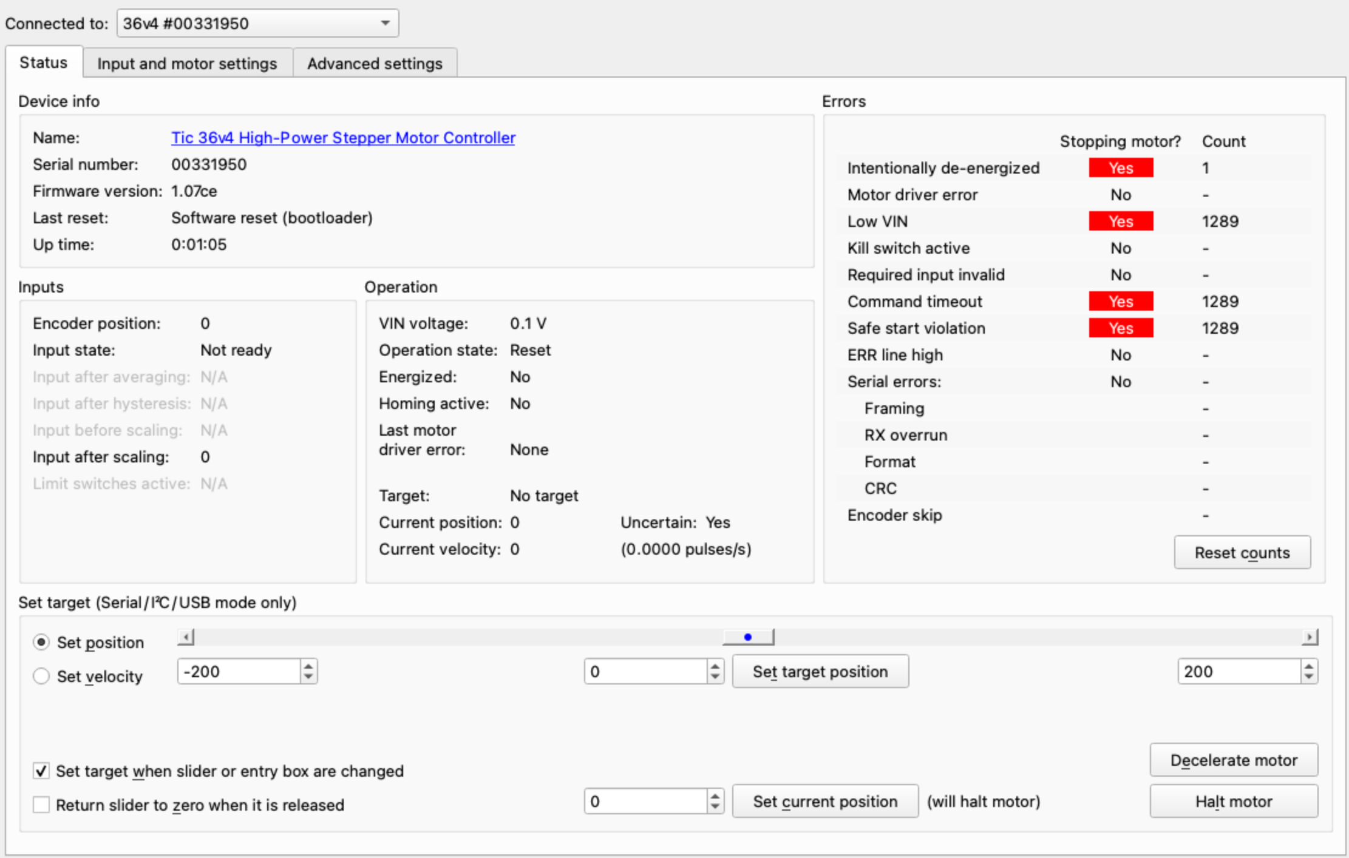

### Step 4 – Set the options on the Pololu Tic

Use the Tic software and set the options as noted below. Comments regarding these selections are in the table, below each screen.

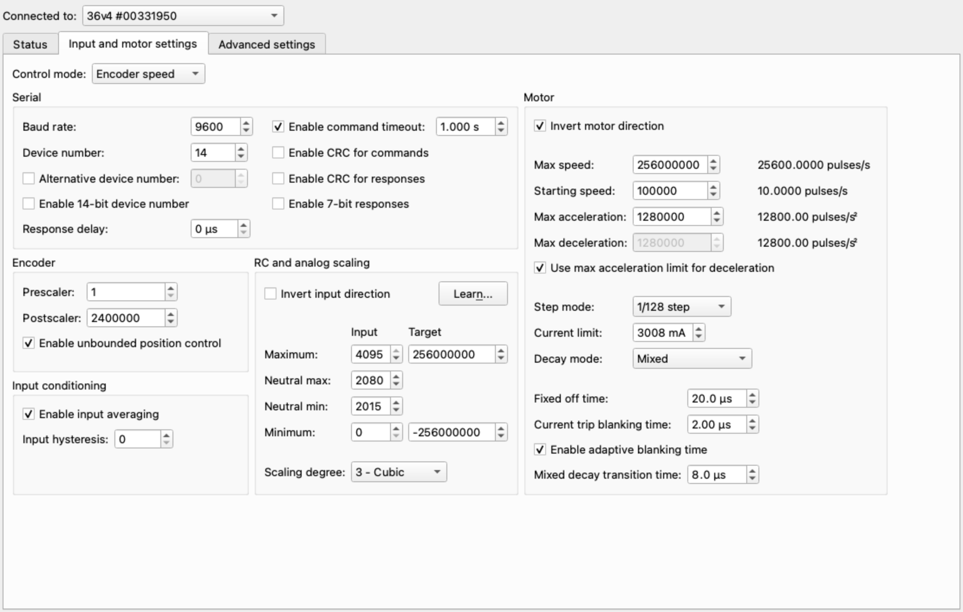

**Ignore This Stuff**

**Ignore This Stuff**

| Option | Set to | Comments |
| --- | --- | --- |
| Control Mode | Encoder Speed | This sets the Tic up for using a rotary encoder to control the speed. If you want to do it differently, consult the Polulu [Tic Stepper Motor Controller User’s Guide](https://www.pololu.com/docs/0J71). |
| Encoder |  |  |
| * Prescaler | 1 | Every time the rotary encoder is changed by this number of detents, the # of post scaler changes is applied to the speed. |
| * Post Scaler | 40,000 | This is in pulses / millisecond. Therefore, each rotation by one indent changes the output from the controller to be 40 pulses / sec.  This setting is key for setting how many rotations of the rotary encoder are req’d to get to max speed. At this setting, it is just under 1.5 full rotations to get up to full speed (from stopped). |
| * Enable Unbounded Position Control | 🗹 |  |
| RC & Analogue Scaling |  |  |
| * Invert input direction | £ | This makes the motor rotate in the correct direction so that the spindle rotates counterclockwise when in “forward”. This is the standard for lathe spindles. |
| * Maximum Target | 25,600,000 | This is in pulses / millisecond, which equates to 25,600 pulses / second. |
| * Minimum Target | -25,600,000 | This is also in pulses / millisecond. This is the reverse speed. |
| * Scaling Degree | 3 – Cubic |  |
| Motor |  |  |
| * Max Speed | 25,600,000 |  |
| * Starting Speed | 0 |  |
| * Max Accel | 400,000 |  |
| * Use Max Accel for Deceleration | ✓ (checked) |  |
| * Step Mode | 1/128 step |  |
| * Current Limit | 3,008 mA |  |
| * Decay Mode | Mixed |  |

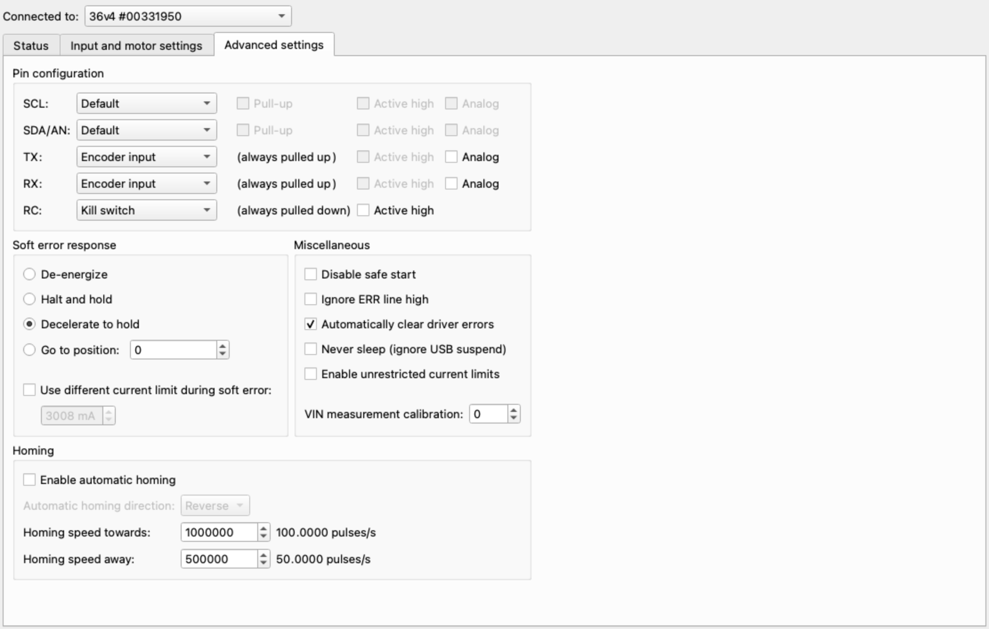

| Option | Set to | Comments |
| --- | --- | --- |
| Pin Configuration |  |  |
| * SCL |  | (left at default) |
| * SDA/AN |  | (left at default) |
| * TX | Encoder Input | Channel B |
| * RX | Encoder Input | Channel A |
| * RC | Kill Switch |  |
| Soft Error Response | Decelerate to Hold |  |

For the stepper motor:

$$Max Stepper Motor Speed= \frac{25,600 \frac{pulses}{sec}*60\frac{sec}{min}}{128\frac{pulses}{step}*200\frac{steps}{rotation}}$$

$$Max Stepper Motor Speed=60 rpm$$

And, as translated to the spindle:

$$Max Spindle Speed= 60 motor rpm* \frac{12 motor pulley teeth}{108 spindle pulley teeth}$$

$$Max Spindle Speed=6.7 rpm$$

# Motor Connections

The spindle stepper motors is connected to the Pololu Tic via a GX-16/4 plug. For the spindle drive, a 3-foot cord is recommended. Stepper motor wire colors shown are for the StepperOnline motors. Check that the one you use matches for the connection needed.

|  |  |  |  |
| --- | --- | --- | --- |
| Stepper Motor | Stepper Motor Wire | Cable Wire Color | GX-16/4 Pin  Yes, I am a Packers fan |
| A+ | Black | Black | 1 |
| A- | Green | Yellow | 2 |
| B+ | Red | Red | 3 |
| B- | Blue | White | 4 |

|  |  |
| --- | --- |
| Conductor Type | Stranded copper |
| Conductor Size | 20 AWG |
| Cable Size | 4 conductors / cable |

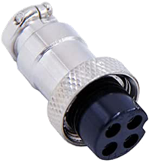

1

2

3

4

Put a ¾” long piece of shrink file onto each one of the stepper motor wires before connecting it to the cable 5 wires.



Connect the cable wires to the stepper motor wires using a lineman’s splice (AKA, the Western Union splice, and shown to the right), and then solder the two together.

Heat the shrink file tubing around each of the joints to insulate it from the other things it could touch.

Alternatively, you can add a back cover to the stepper motor. This gives a secure way to attach the signal wires to the motor. These are available from a number of sources, and they can even be 3D printed. Look for one online using the term “stepper motor back cover”.

In this case, connect the stepper motor to the GX-16/4 jack as:

|  |  |  |
| --- | --- | --- |
| Stepper Motor | Stepper Motor Wire | GX-16/4 Pin |
| A+ | Black | 1 |
| A- | Green | 2 |
| B+ | Red | 3 |
| B- | Blue | 4 |

# Attaching the Stepper Motor to the Headstock

### Step 1 - Ensure the bracket is ready to attach to the headstock

The stepper motor attaches to the headstock as shown in the picture to the right.

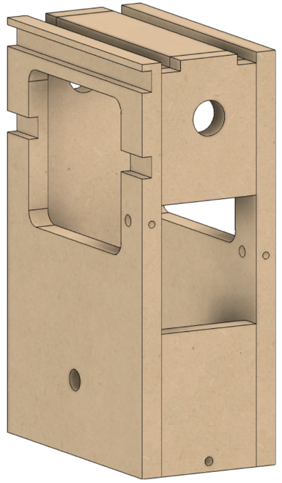

If you purchased the kit we supply, the holes on the left and right of the headstock are already set properly.

If you built it yourself, you will now need to drill the holes for the screws on the right side of the headstock. As noted in the case building instructions, these need to be set based on the alignment of the bracket.

**NOTE:** The picture on the right is of the assembly on the original MDF rose engine lathe. On version 2.0, there is no need for the cutout in the base to accommodate the bracket.



### Step 2 – Attach the spindle pulley to the spindle flange

Attach the spindle pulley to the spindle flange. There are 4 screws (#502) for this. One is indicated here.

### Step 3 – Attach the spindle motor to the bracket

Attach the stepper motor to the bracket using 4 screws (#504). One is indicated here.

### Step 4 – Attach the motor drive pulley to the stepper motor

Secure the 12-tooth drive pulley to the stepper motor’s spindle.

### 

### Step 5 – Attach the spindle motor bracket to the headstock

Attach the bracket to the headstock on both sides. There are two screws and two spacers (they look like thick washers). The spacers are installed between the bracket and the headstock. They are held onto the headstock using barrel nuts. Do not tighten them just yet.

### Step 6 – Install the timing belt

Install the timing belt (item #501).

### Step 7 – Tighten it down

Snug the bracket so that the timing belt is tight enough that it won’t slip, but not so tight that it stretches. Once it is set, tighten the two bolts (#503) holding the bracket to the headstock. They need to be tight enough to not slip, but do not over tighten them as that will cause the barrel nuts to pull thru the MDF.

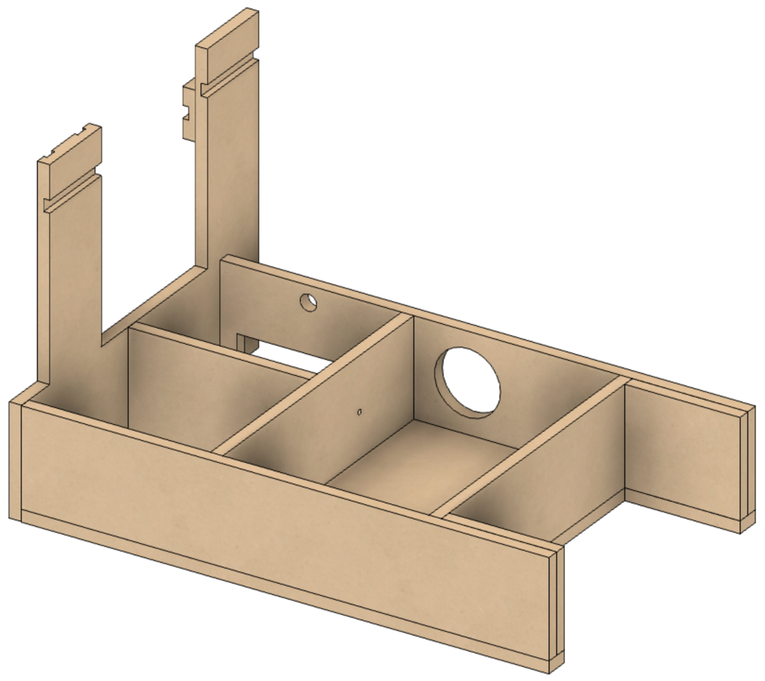The stepper motor’s cable needs to be fed thru the hole in the back of the headstock,

and continue out of the lathe thru the hole in the back of the bed.

# Document Version History

|  |  |  |
| --- | --- | --- |
| Ver | Date | Comment |
| 1.0 | 22 January 2021 | Initial document |

To the extent that material may appear to be infringed, we assert that such alleged infringement is permissible under fair use principles in U.S. copyright laws. If you believe material has been used in an unauthorized manner, please contact me at [ColvinTools@Gmail.com](mailto:ColvinTools@Gmail.com).

The layout of the Printed Circuit Board (PCB) is copyright Ed French and is used with his permission.

Permission is not granted to manufacture these for sale.